Aim: To obtain the best fit line over single feature scattered datapoints using Linear Regression IDE: Google Colab
Theory:
Linear regression is a method for determining the best linear relationship between two variables X and Y. If variables X and Y are uncorrelated, it is pointless embarking upon linear regression. However, if a reasonable degree of correlation exists between X and Y then linear regression may be a useful means to describe the relationship between the two variables. The usual approach is to use the least-squares method, which minimizes the squared difference between the actual data points and a straight line. Let [x_{i},y_{i}], i = 1,2,3,….,N be the N pairs of data values of the variables X and Y. The straight-line relating X and Y is y = mx + c, where m and c are the gradient and constant values (to be determined) defining the straight line. Thus, y(x_{i}) - y_{i} is the difference between the line and data point i (see Fig. 1). Taking all the data points, we seek values of m and c that minimize the squared difference SD.
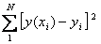
This is achieved by calculating the partial derivatives of SD with respect to m and c and finding the pair [m,c] such that SD is at a minimum.
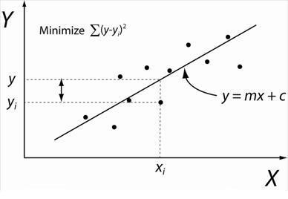
Figure 1: Illustration of Linear Regression. Linear least squares regression, the idea is to find the line y = mx + c that minimizes the mean squared difference between the line and the data points

Batch Gradient Descent:
Gradient Descent is an optimization algorithm used for minimizing the cost function in various machine learning algorithms. It is basically used for updating the parameters of the learning model. Batch gradient descent which processes all the training examples for each iteration of gradient descent. But if the number of training examples is large, then batch gradient descent is computationally very expensive.

Let m be the number of training examples. Let n be the number of features.

Algorithm for batch gradient descent :
Let h_{θ}(x) be the hypothesis for linear regression. Then, the cost function is given by: Let Σ represents the sum of all training examples from i=1 to m. J_{train}(θ) = (1/2m) Σ( h_{θ}(x^{(i)}) - y^{(i)})²

Repeat {
θj = θj – (learning rate/m) * Σ( h_{θ}(x^{(i)}) - y^{(i)})x_{j}^{(i)}
For every j =0 …n
}
Where x_{j}^{(i)} Represents the j^{th} feature of the i^{th} training example. So if m is very large(e.g. 5 million training samples), then it takes hours or even days to converge to the global minimum.That’s why for large datasets, it is not recommended to use batch gradient descent as it slows down the learning.

Pre Lab Exercise:
a. Explain the meaning of linear regression
Linear regression is a statistical method used to model the relationship between an independent variable (X) and a dependent variable (Y) by fitting a straight line: y=mx+c
It predicts continuous values by minimizing the error between actual and predicted outputs. _________________________________________________________________
________________________________________________________________________ b. Write three applications of linear regression
- House price prediction___________________________________________________
- Sales forecasting_______________________________________________________
- Stock market trend analysis______________________________________________
c. Write three advantages of linear regression
1. Simple and easy to implement_____________________________________________
2. Easy to interpret results___________________________________________________
3. Works well for linearly related data_________________________________________
________________________________________________________________________ d. Write three limitations of linear regression
- Assumes linear relationship (not always true)_________________________________
- Sensitive to outliers_____________________________________________________
- Cannot handle complex patterns__________________________________________
________________________________________________________________________
Methodology:
- Load the basic libraries and packages
- Load the dataset
- Analyse the dataset
- Pre-process the data
- Visualize the Data
- Separate the feature and prediction value columns
- Write the Hypothesis Function
- Write the Cost Function
- Write the Gradient Descent optimization algorithm
- Apply the training over the dataset to minimize the loss
- Find the best fit line to the given dataset
- Observe the cost function vs iterations learning curve

Program (Code):
To be attached with
# Step 1: Import libraries
import numpy as np
import pandas as pd
import matplotlib.pyplot as plt

# Step 2: Create sample dataset
X = np.array([1,2,3,4,5,6,7,8,9,10])
Y = np.array([2,4,5,4,5,7,8,9,10,12])

# Step 3: Normalize data (optional but good practice)
X = (X - X.mean()) / X.std()

# Step 4: Initialize parameters
m = 0
c = 0
lr = 0.01
epochs = 100

n = len(X)

cost_history = []

# Step 5: Gradient Descent
for i in range(epochs):
Y_pred = m*X + c

# Cost (MSE)
cost = (1/(2*n)) * np.sum((Y_pred - Y)**2)
cost_history.append(cost)

# Derivatives
dm = (1/n) * np.sum((Y_pred - Y)*X)
dc = (1/n) * np.sum(Y_pred - Y)

# Update
m = m - lr*dm
c = c - lr*dc

print("Slope (m):", m)
print("Intercept (c):", c)

# Step 6: Plot scatter (before line)
plt.scatter(X, Y)
plt.title("Scatter Plot (No Line)")
plt.show()

# Step 7: Plot best fit line
plt.scatter(X, Y)
plt.plot(X, m*X + c)
plt.title("Best Fit Line")
plt.show()

# Step 8: Cost vs Iterations
plt.plot(cost_history)
plt.title("Cost vs Iterations")
plt.xlabel("Iterations")
plt.ylabel("Cost")
plt.show()

Results:
To be attached with
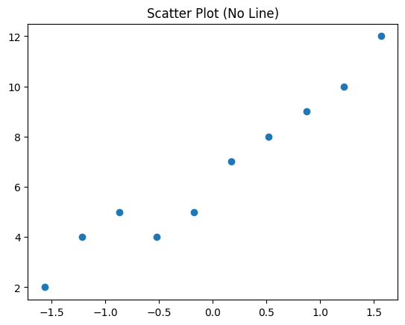
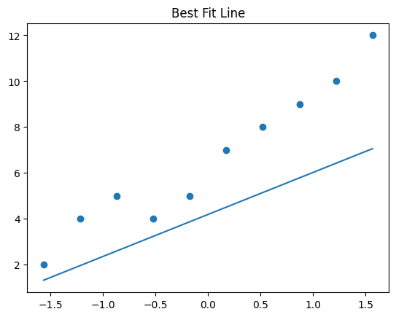
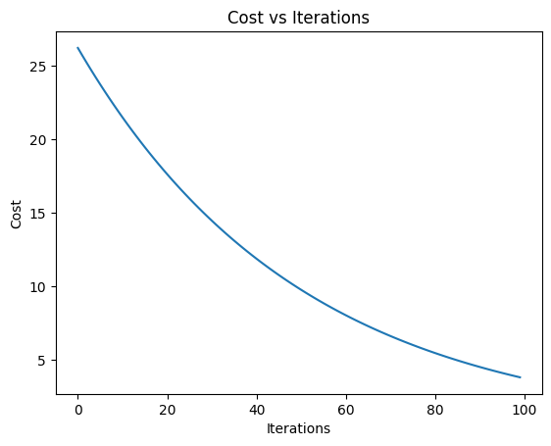
- Datapoints scattering (without best fit line)
• Scatter plot shows distribution of data points
• No clear line before training
- Scatter plot showing the Best fit line in the last iteration of training
• Straight line fits data after training
• Shows linear relationship between X and Y

Observation and Result Analysis:
- Nature of the dataset
- Dataset shows a positive linear relationship__________________________________
- As X increases, Y also increases____________________________________________
________________________________________________________________________

- During Training Process
- Cost function decreases with iterations______________________________________
- Parameters (m, c) get optimized___________________________________________
- Model gradually improves prediction_______________________________________
________________________________________________________________________

- After the training Process
- Best fit line obtained____________________________________________________
- Error minimized________________________________________________________
- Model can predict new values_____________________________________________
________________________________________________________________________

Post Lab Exercise:
- What are the major assumptions considered in linear regression
- Linear relationship between variables_______________________________________
- No multicollinearity_____________________________________________________
- Homoscedasticity (constant variance)_______________________________________
- No autocorrelation______________________________________________________
- Normally distributed errors_______________________________________________
________________________________________________________________________
- Why MSE is used instead of MAE for calculating the loss function
- MSE penalizes larger errors more (squared term)______________________________
- Differentiable → easier for gradient descent__________________________________
- Helps faster convergence_________________________________________________
________________________________________________________________________
- How can the behaviour of outliers be understood while dealing with the unseen dataset
- Use boxplot / IQR method________________________________________________
- Z-score detection_______________________________________________________
- Remove or cap extreme values____________________________________________
- Use robust models if needed______________________________________________
________________________________________________________________________

- Derive the Normal Equation for the Linear Regression.
Final formula:
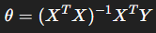
Where:
- X = feature matrix
- Y = target values
- θ = parameters

